Contents

1. CREATE Storage Objects 2

2. Generate Test Data in Storage Layers 3

2.1.1. Data analysis and preparation 3

2.1.2. Source 4

2.1.3. Cleansing area 5

2.1.4. 3NF 7

2.1.5. Result 9

3. SQL*Plus 10

3.1.1. Connection 10

3.1.2. First select 11

3.1.3. Set timing on 11

3.1.4. Explain plan for 12

3.1.5. Save results 13

# CREATE Storage Objects

Format Physical Objects of your Business Model according to the templates.

Task Results:

Create scripts for objects:

* Scripts put on Git
* Storage Layers Objects

All scripts were modified accordingly to template and guidance and now stored at dwso->bl_dm->tables.

# Generate Test Data in Storage Layers

Proceed with loading of Locations data into the normalized level.

Task Results:

* Scripts put on Git
* Storage Layers Objects test data select screenshots

**Algorithm**

### Data analysis and preparation

1. About data: We have three tables in the denormalized form:

Here just all data about countries.

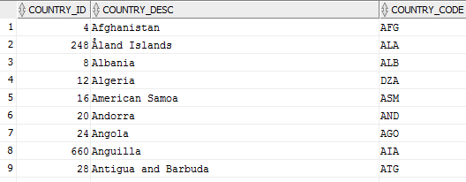

Here we see table which connects countries with regions. It’s in the 2 NF.

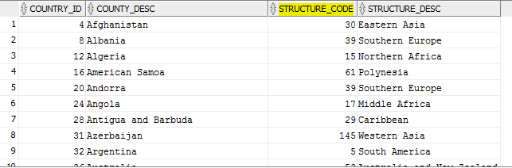

Here we see table which contains and connects 3 levels: World->Continents->Regions.

Parent code in child refers to child code of parent.

(Parent_Code_Continent=Child_Code_World

Parent_Code_Region=Child_Code_Continent)

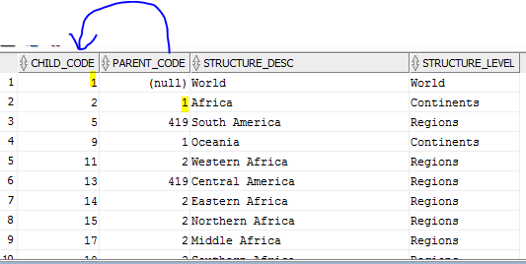

**So, we have the following hierachy:**

World->Continents->Regions->Countries.

1. Created directory on VM (shared folder ETL)

A directory on the server file system is where external binary file LOBs and external table data are located.

CREATE OR REPLACE DIRECTORY etl AS '/media/sf_ETL';

### Source

1. Created user SRC and gave grants on select, create any table, and read, write from directory

CREATE USER SRC

  IDENTIFIED BY 123456

  DEFAULT TABLESPACE users

  QUOTA UNLIMITED ON users

  TEMPORARY TABLESPACE temp

  PROFILE default;

grant create session to SRC;

EXEC system.grants_mgmt.grant_blat('CREATE ANY TABLE', 'SRC');

EXEC system.grants_mgmt.grant_blat('SELECT ANY TABLE', 'SRC');

EXEC system.grants_mgmt.grant_blat('READ,WRITE ON DIRECTORY ETL', 'SRC');

1. Runned scripts from the task and created 3 tables:

All files (.tab) were put into the directory ETL.

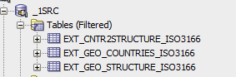

Tables are already loaded with data because external tables enable to access data in external sources as if it were in a table in the database.

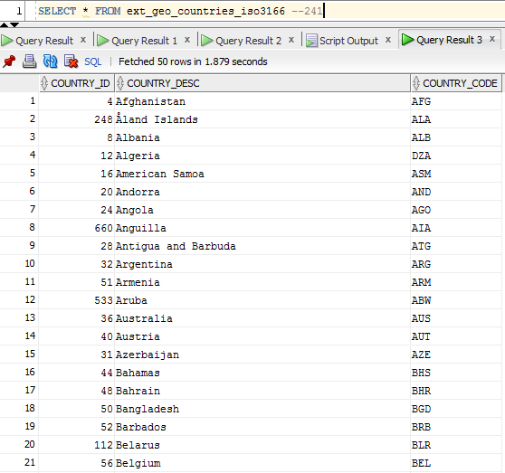

### Cleansing area

Here I don’t create wrk_ and cl_ tables, because we don’t need to clean or modify our data, therefore it will be enough one table to improve performance (reading from table **is faster** than reading from disk).

But if I did, wrk tables would have the same structure as external tables, and cleansing tables(as I did in this step) are more like the 3NF (but can (not necessarily) have some differences).

1. Created user BL_CL and gave grants on select, create any table.

CREATE USER BL_CL

  IDENTIFIED BY 123456

  DEFAULT TABLESPACE users

  QUOTA UNLIMITED ON users

  TEMPORARY TABLESPACE temp

  PROFILE default;

grant create session to BL_CL;

EXEC system.grants_mgmt.grant_blat('CREATE ANY TABLE', 'BL_CL');

EXEC system.grants_mgmt.grant_blat('SELECT ANY TABLE', 'BL_CL');

1. Created tables, which are close to the 3NF,but without any constraints.

CREATE TABLE cl_global

(

global_id NUMBER(10,0),

global_desc VARCHAR2 ( 200 CHAR )

);

CREATE TABLE cl_continents

(

continent_id NUMBER(10,0),

continent_desc VARCHAR2 ( 200 CHAR ),

global_id NUMBER(10,0)

);

CREATE TABLE cl_regions

(

region_id NUMBER(10,0),

region_desc VARCHAR2 ( 200 CHAR ),

continent_id NUMBER(10,0)

);

CREATE TABLE cl_countries

(

country_id NUMBER(10,0),

country_desc VARCHAR2 ( 200 CHAR ),

country_code VARCHAR2 ( 3 ),

region_id NUMBER(10,0)

);

1. Gave needed grants, so user BL_CL can select from SRC tables (run it from the system).

exec system.grants_mgmt.grant_blat ('SELECT', 'SRC','ext_geo_countries_iso3166','BL_CL');

exec system.grants_mgmt.grant_blat ('SELECT', 'SRC','ext_geo_structure_iso3166','BL_CL');

exec system.grants_mgmt.grant_blat ('SELECT', 'SRC','ext_cntr2structure_iso3166','BL_CL');

1. Inserted data into them from external tables.

INSERT INTO cl_global

(global_id, global_desc

)

SELECT child_code,

structure_desc

FROM src.ext_geo_structure_iso3166

WHERE structure_level='World';

INSERT INTO cl_continents

(continent_id, continent_desc,global_id

)

SELECT child_code,

structure_desc,

parent_code

FROM src.ext_geo_structure_iso3166

WHERE structure_level='Continents';

INSERT INTO cl_regions

(region_id, region_desc,continent_id

)

SELECT child_code,

structure_desc,

parent_code

FROM src.ext_geo_structure_iso3166

WHERE structure_level='Regions';

INSERT INTO cl_countries

(country_id, country_code,country_desc, region_id

)

COMMIT;

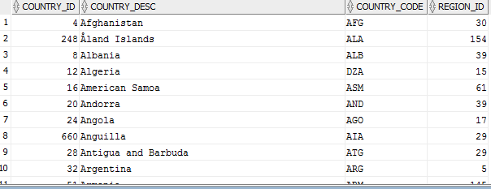

### 3NF

1. Created user BL_3NF and gave grants on select, create any table.

CREATE USER BL_3NF

IDENTIFIED BY 123456

DEFAULT TABLESPACE users

QUOTA UNLIMITED ON users

TEMPORARY TABLESPACE temp

PROFILE default;

grant create session to BL_3NF;

EXEC system.grants_mgmt.grant_blat('CREATE ANY TABLE', 'BL_3NF');

EXEC system.grants_mgmt.grant_blat('SELECT ANY TABLE', 'BL_3NF');

1. Created tables in the 3NF with all required constraints (PK,FK).

* Country code is NULL, because one row (Channel Islands) doesn’t have it.

CREATE TABLE globals

(

global_id NUMBER(10,0) PRIMARY KEY ,

global_desc VARCHAR2 ( 200 CHAR ) NOT NULL

);

CREATE TABLE continents

(

continent_id NUMBER(10,0) PRIMARY KEY ,

continent_desc VARCHAR2 ( 200 CHAR ) NOT NULL,

global_id NUMBER(10,0) NOT NULL,

CONSTRAINT gk_glob FOREIGN KEY (global_id) REFERENCES globals(global_id)

);

CREATE TABLE regions

(

region_id NUMBER(10,0) PRIMARY KEY,

region_desc VARCHAR2 ( 200 CHAR ) NOT NULL,

continent_id NUMBER(10,0) NOT NULL,

CONSTRAINT fk_cont FOREIGN KEY (continent_id) REFERENCES continents(continent_id)

);

CREATE TABLE countries

(

country_id NUMBER(10,0) PRIMARY KEY NOT NULL,

country_desc VARCHAR2 ( 200 CHAR ) NOT NULL,

country_code VARCHAR2 ( 3 ),

region_id NUMBER(10,0)NOT NULL ,

CONSTRAINT fk_reg FOREIGN KEY (region_id) REFERENCES regions(region_id)

);

1. Gave needed grants, so user BL_3NF can select from BL_CL tables (run it from system).

exec system.grants_mgmt.grant_blat ('SELECT', 'BL_CL','cl_continents','BL_3NF');

exec system.grants_mgmt.grant_blat ('SELECT', 'BL_CL','cl_countries','BL_3NF');

exec system.grants_mgmt.grant_blat ('SELECT', 'BL_CL','cl_global','BL_3NF');

exec system.grants_mgmt.grant_blat ('SELECT', 'BL_CL','cl_regions','BL_3NF');

1. Inserted data into them from BL_CL.

INSERT INTO globals

SELECT * FROM bl_cl.cl_global;

INSERT INTO continents

SELECT * FROM bl_cl.cl_continents;

INSERT INTO regions

SELECT * FROM bl_cl.cl_regions;

INSERT INTO countries

SELECT * FROM bl_cl.cl_countries;

COMMIT;

### Result

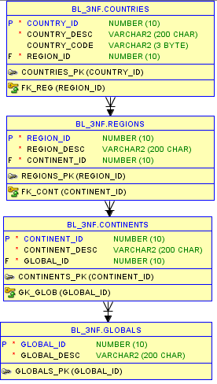

All scripts are also in the folder.

# SQL*Plus

Connect to a database via SQL*Plus client and do next steps:

* Show execution plans in SQL*Plans
* Set timing on
* Run script
* Save data to file

Task Results:

* Put screenshots on Git.

### Connection

Run sqlplus from terminal in Linux. Login and connected as BL_3NF user.

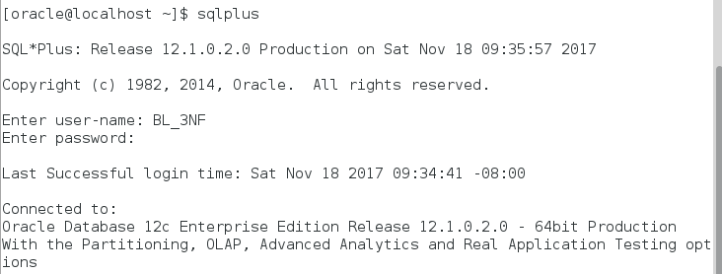



### First select

Run simple select without any additional settings.

* Sign **‘/’** is used because sqlplus gives an opportunity to write in several lines, and using ‘/’ we show that the command is ready.

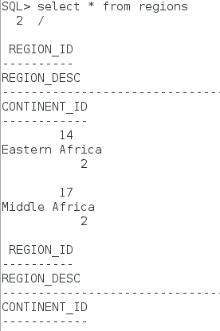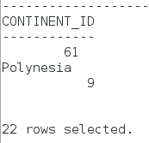

### Set timing on



With this option after each query we can see elapsed time (how much time was taken)

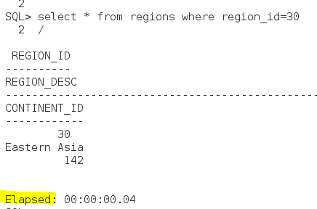

### Explain plan for

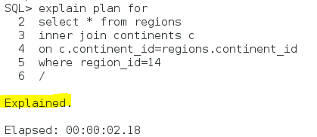

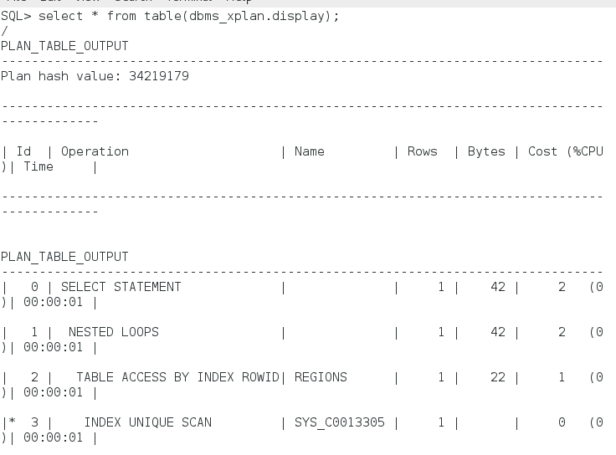 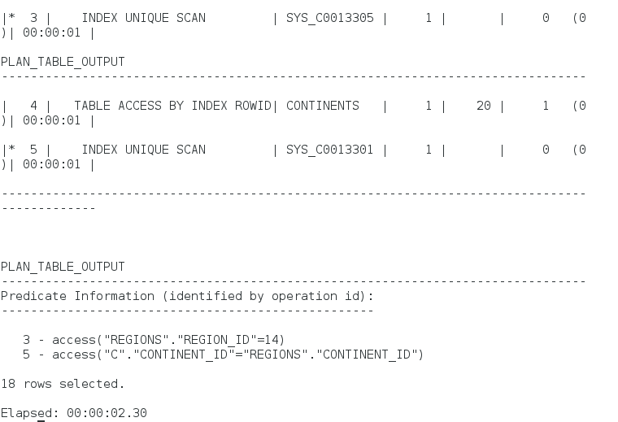

### Save results

#### Save the query

The last query was saved in the file test.sql

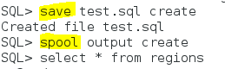

The next query was added to the previous in the file test.sql

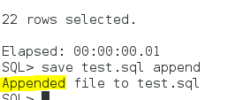

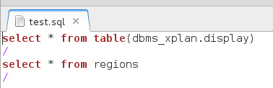

#### Save result of the query

The result of the query was saved in the file output.lst



The result of the query was saved in the file spool.txt



All files also in the folder.